M.Sc. Geoinformatics Engineering

Geoinformatics Project

Project Technical Report

**COMPARISION OF SPATIO-TEMPORAL BURNED AREA DISTRIBUTION USING GOOGLE EARTH ENGINE**

**Tutor:** Prof. Venuti Giovanna

(Chair of Geoinformatics Engineering Department, Politecnico di Milano)

**Co-Tutor:** Dr.Daniela Stroppiana

(Senior Researcher, CNR-IREA)

**Authors:** Rishikesh Miriyala (10814272)

rishikesh.miriyala@mail.polimi.it

Sriram Krishnasamy Seenivasan (10888750)

sriram.krishnasamy@mail.polimi.it

Ghulam Abbas Zafari (10944305)

ghulamabbas.zafari@mail.polimi.it

**GitHub Link:** [**https://github.com/Sri603/Comparision-of-spatio-temporal-BAD-using-GEE.git**](https://github.com/Sri603/Comparision-of-spatio-temporal-BAD-using-GEE.git)

# ABSTRACT

The Spatio-temporal distribution of burned areas (BA) is critical for understanding fire dynamics and their ecological, climatic, and socio-economic impacts. This study provides a comprehensive comparison of burned area estimates derived from major global datasets, including MODIS MCD64 and FIRMS, utilizing multi-annual datasets in Google Earth Engine (GEE). We analyze spatial and temporal patterns of burned areas across Australia, highlighting variability influenced by land use practices and climatic factors, thereby contributing to improved monitoring methodologies.

Our approach consists of extracting information on wildfires from multi-spectral satellite imagery. First, we create a comprehensive image incorporating relevant factors such as burned areas, forest loss, land use/land cover, and land surface temperature. Active fires and burned areas are extracted by filtering data based on date and region of interest, with appropriate bands and scales, allowing for detailed analysis of fire dynamics.

Our findings set the groundwork for further analysis of the factors affecting wildfire distribution in Australia, while providing preliminary insights and methodologies for future research in fire monitoring and management.

# KEYWORDS:

Burned Area (BA), Spatio-Temporal Analysis, Google Earth Engine (GEE), MCD64, Land Use Land Cover, Global Forest Cover, Multi-Annual Analysis.

Table of Contents

ABSTRACT 2

KEYWORDS: 2

Ⅰ. INTRODUCTION: 4

Ⅱ. SPECIFICATIONS: 4

A. Objectives 4

B. Functionalities Used 5

i. Software and Tools Used 5

ii. Input Products Collection 5

C. Analysis and Approach 5

ⅰ. Clipping the Region of Interest (ROI) 5

ⅱ. Classification of Fire Severity Using MCD64A1 6

ⅲ. Generating Burned Area Masking Using Threshold Values 6

ⅳ. Spatial Analysis 7

ⅴ. Temporal Analysis 8

Ⅲ. IMPLEMENTATION 9

A. Data Acquisition and Processing 10

ⅰ. Data Collection 10

ⅱ. Data Cleaning and Processing 10

ⅲ. Feature Extraction 10

B. Burned Area Classification Approach 10

ⅰ. Burn Mask Creation: 10

ⅱ. Predictor Image Compilation: 11

C. Spatial and Temporal Analysis 11

ⅰ. Spatial Analysis: 11

ⅱ. Temporal Analysis 11

Ⅳ. Results: 12

A. Land Cover Distribution: 12

B. NDVI Seasonal and Annual Patterns 13

C. Burned Area Analysis: 13

D. Forest Loss Trends and Hotspots 14

ⅴDiscussion: 14

ⅵConclusion: 15

REFERENCES: 16

# Ⅰ. INTRODUCTION:

Australia experiences a significant number of bushfires, particularly during dry summer months. These fires have devastating impacts on the environment, human communities, and the economy. The distribution of burned areas across Australia is not uniform and varies considerably depending on factors such as climate, vegetation, and human activities. Understanding the trends in burned area distribution, the impacts of fires, and effective management strategies is crucial for mitigating the risk and promoting sustainable land management [1].

The distribution of burned areas in Australia is influenced by a complex interplay of factors. Hotter and drier conditions increase the risk of fire ignition and spread. Key meteorological variables include temperature, precipitation, humidity, wind speed, and wind direction. For instance, the 2019–2020(black summer) wildfire season was exacerbated by ongoing drought, low soil moisture, and heatwaves. Human activities, such as land clearing, agricultural practices, and the presence of infrastructure, also influence fire regimes and the distribution of burned areas [1].

The impacts of bushfires are far-reaching. Fires can result in the loss of life, damage to property, and disruption to essential services. They also have significant environmental consequences, including loss of biodiversity, habitat destruction, soil erosion, and reduced water quality. Bushfires release substantial amounts of greenhouse gases into the atmosphere, exacerbating climate change. Furthermore, they have socioeconomic impacts, affecting tourism, agriculture, and timber production.

Managing bushfires effectively requires various approach. Prevention strategies, such as reducing fuel loads, controlling ignition sources, and implementing fire-resistant building practices, are critical for minimizing the risk of fires. Early detection and rapid response are essential for containing fires and reducing their impact. This involves investing in advanced monitoring systems, deploying firefighting resources, and ensuring the effectiveness of community fire management programs [2].

Australia has a long history of fire management, and the country's approach has evolved over time. The focus has shifted from suppression to a more holistic approach that incorporates ecological considerations. This involves managing landscapes to reduce the intensity and spread of fires, promoting fire-tolerant species, and allowing for natural fire regimes in certain ecosystems [3].

# Ⅱ. SPECIFICATIONS:

## A. Objectives

The primary objectives of this study are:

1. **Dataset Comparison:** Evaluate the spatial and temporal discrepancies from major global burned area datasets to assess their reliability and consistency.
2. **Environmental Impact Assessment:** Analyze the influence of environmental factors such as Land Use Land Cover (LULC), temperature, and forest loss on the distribution of burned area across Australia.
3. **Visualization and Interpretation:** Develop interactive maps and charts for better understanding and interpretation of fire patterns across various regions of Australia.
4. **Automation and Scalability:** Utilize GEE’s cloud computing capabilities to ensure scalability and automation of the analysis across multiple timeframes and regions.

## B. Functionalities Used

### i. Software and Tools Used

* **Google Earth Engine (GEE):** A cloud-based platform for global-scale geospatial analysis that processes a variety of geographical data at scale and handles large geographical datasets.
* **QGIS:** An open-source cross-platform GIS application that supports viewing, editing, printing, map creation and analyzing geospatial data.

### ii. Input Products Collection

The analysis relies on multiple geospatial datasets available in GEE:

|  |  |  |
| --- | --- | --- |
| **Dataset** | **Description** | **Purpose** |
| MCD64A1 | Modis Burned Area | Burned area |
| FIRMS | Active Fire Data | Fire Intensity Classes |
| HANSEN | Global Forest change | Forest Fire Impact |
| MODIS LULC  MCD12C1 | Land Use Land Cover | Land Types Analysis |
| MODIS LST  MOD11A1 | Land Surface Temperature | Temperature Correlation |
| MODIS NDVI  MOD13A2 | Normalize Difference Vegetation Index | Pre/Post fire assessment |

Table : Global Datasets

## C. Analysis and Approach

This section describes the step-by-step approach used in implementing the burned area analysis and key methodologies employed.

### ⅰ. Clipping the Region of Interest (ROI)

* **Importing Global Datasets:** Utilize GEE’s API to access global datasets pertinent to burned area analysis, such as Landsat or Sentinel-2 imagery.
* **Filtering Data by Date and Clip to ROI:** Apply temporal filters to select data within specific date ranges (2019 to 2023) and spatially clip the dataset to focus on the ROI, e.g., Australia [4].
* **Select Relevant Bands:** Choose specific spectral bands necessary for the analysis, such as those used in calculating indices like BurnDate.

By clipping datasets to the ROI, the volume of data processed is reduced, mitigating the risk of exceeding GEE’s memory limits. This approach aligns with methodologies discussed in the study [5].

Detecting and classifying burned areas is essential for understanding fire dynamics and their ecological impacts. Two prominent satellite-derived products used in the context are the FIRMS (MODIS MCD64A1) enhances the accuracy and efficiency of the process [6].

### ⅱ. Classification of Fire Severity Using MCD64A1

The MODIS MCD64A1 product provides global burned area mapping at a 500-meter resolution. It employs an improved algorithm that reduces omission errors and enhances the detection of smaller burns. The product includes data layers such as Burn Date, Burn Date Uncertainty, and Quality Assurance, which are instrumental in assessing fire severity [7].

### ⅲ. Generating Burned Area Masking Using Threshold Values

By applying specific threshold values to active fire data, it is possible to generate burned area masks that delineate the extent of fire-affected regions (Figure 1). This approach involves analyzing spectral indices sensitive to fire effects and setting thresholds to classify burned and unburned areas [9].

Figure : Burned Area -Australia

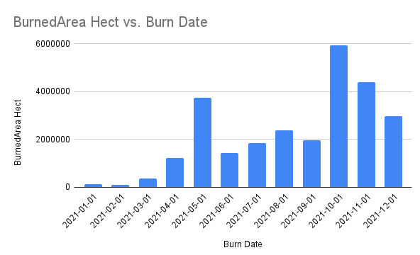

Figure : Monthly Burned Area in Australia 2021

### ⅳ. Spatial Analysis

* **Evaluating Land Cover Classes Affected by Fires:** Accessing the impact of fires on various lands covers classes requires the integration of burned area data with Land Use/ Land Cover (LULC) datasets at 1000m scale. By overlaying these datasets, one can identify which land cover types are most affected by fires. For instance, a study in Europe analysed transitions between LULC classes and burned areas over two decades, revealing significant losses in forests and arable lands due to wildfires (Figure 3) [10].

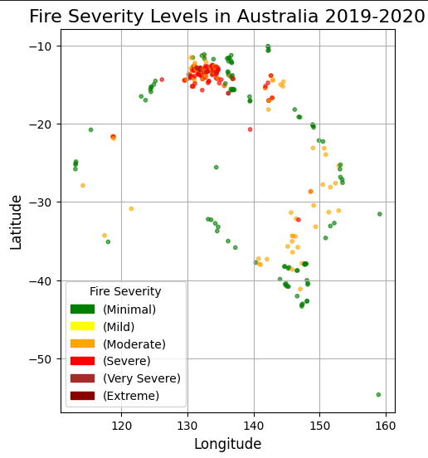

Figure : Fire Severity points

* **Calculating Areas of Each Land Cover Trend During the Year:** Quantifying annual changes in land cover classes involves calculating the area of each class before and after fire events. This can be achieved using Geographic Information System (GIS) tools to process LULC datasets and detect changes in 2022 at a scale of 500m. Such analyses help in understanding the dynamics of land cover changes and the extent of areas affected by fires (Figure 4) [10].

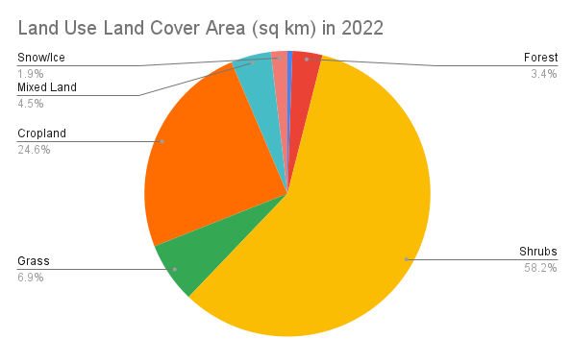

Figure : Land Use and Land Cover areas Australia

Conducting a comprehensive analysis of burned areas involves spatial and temporal assessments, as well as the application of machine learning classifiers. Below are the methodologies for each component

### ⅴ. Temporal Analysis

* **Creating Time Series for NDVI Patterns:** The Normalized Difference Vegetation Index (NDVI) is a key indicator of vegetation health. By generating time series of NDVI data, researchers can monitor vegetation dynamics and assess the impact of fires on vegetation health over time. This involves processing satellite imagery to extract NDVI values at different time intervals at a scale of 1000m(Figure 5) [10].

Figure : NDVI Time Series

* **Evaluating During the Period 2011 to 2023:** Focusing on specific time frame such as 2011 to 2023, allows for the assessment of the recent trends in the vegetation health and fire impacts. Analysing NDVI time series can reveal patterns of recovery or degradation of post fire events [10].
* **NDVI Anomaly:** The NDVI anomaly analysis was conducted to evaluate changes in vegetation condition across Australia between the pre-fire year (2020) and the post-fire year (2021). This helps assess the ecological impact of wildfires, particularly in terms of vegetation loss and potential regrowth.
* Negative anomaly values (Red): Indicate a decline in vegetation health or cover in 2021 compared to 2020, suggesting areas potentially affected by wildfires, drought, or land degradation.
* Positive anomaly values (Green): Indicate vegetation regrowth or improvement, possibly due to recovery post-fire, favourable climate, or reforestation.

Figure : NDVI Anomaly 2020 VS 2021

* **Analysing Fire Severity Patterns:** Fire severity refers to the extent of environmental change caused by fire. By examining post-fire NDVI reductions, researchers can infer the severity of fires across different regions and time periods. This analysis aids in identifying areas that require restoration or further monitoring [10].

# Ⅲ. IMPLEMENTATION

In the implementation phase, we apply techniques to analyse burned areas using geospatial dataset and machine learning algorithms. focuses on applying methodologies and techniques required to analyse. This section encompasses data acquisition, processing burned area classification, spatial and temporal analysis.

## A. Data Acquisition and Processing

### ⅰ. Data Collection

* **Datasets:** The study utilizes datasets from Google Earth Engine (GEE), including MODIS MCD64A1, MODIS NDVI, LULC, Land Surface Temperature (LST), and SUOMI VIIRS. These datasets provide comprehensive information on burned areas, vegetation health, land cover types, and temperature variations.
* **Region of Interest (ROI):** The study focuses on Australia, defined using administrative boundary layers from the Global Administrative Unit Layers (GAUL) dataset.
* **Analysis Period:** In the implementation phase, we apply techniques to analyse burned areas using geospatial dataset and machine learning algorithms. focuses on applying methodologies and techniques required to analyse. This section encompasses data acquisition, processing burned area classification, spatial and temporal analysis.

### ⅱ. Data Cleaning and Processing

* **Alignment:** Datasets are reprojected and rescaled to ensure uniform spatial resolution and coordinate systems, facilitating accurate overlay and analysis.
* **Temporal Adjustment:** The date ranges of datasets are adjusted to align with the study period, ensuring consistency across temporal analysis.
* **Calculations:** Burned area extents are computed, LULC types are classified, and NDVI values are calculated to assess vegetation health.

### ⅲ. Feature Extraction

* **Burned Area:** Derive burn dates, assess fire severity, and calculate burned areas from the MCD64A1 dataset at a scale of 500m
* **Active Fires:** FIRMS dataset is filtered by date and temperature (T21) band, categorizing the pixels at a scale of 500m
* **Land Surface Temperature (LST):** MOD11A1 that collects daily temperature at 1km accuracy is used during the year 2019 and mean value is calculated further a map is generated and extracted at a scale of 1000m.
* **LULC Analysis:** Calculate areas of different land cover types affected during the fire event at a scale of 500m.
* **NDVI:** NDVI band is selected from the MODIS dataset during period of 2010 to 2021 to analyse the loss and gain trend of green cover in Australia at a scale of 1000m.
* **NDVI Anomaly:** The change in green cover after the major fire event is compared i.e. 2020 and 2021 to analyse the regrowth of the vegetation.

## B. Burned Area Classification Approach

ⅰ. Burned Area Extraction: A burned area layer is generated using the MCD64A1 dataset by selecting pixels corresponding that are burned. A burned mask is created by computing each pixel that is burned and calculating the area in hectares (Figure 7).

Figure : Burned Area Polygons

## C. Spatial and Temporal Analysis

### ⅰ. Spatial Analysis:

* **Burned Area Distribution:** Thematic maps are created to visualize the spatial distribution of burned areas across Australia.
* **Active Fires Severity:** Active fires are categorized by severity levels to assess immediate impact (Figure 8).
* **Land Cover Impact:** Analysis of MODIS LULC data determines the extent of land cover types affected by fires.
* **Temperature Variation:** The LST data monitors temperature variations during forest fire events, providing insights into fire behaviour.
* **Forest Loss Assessment:** Global Forest Change (GFC) data is used to calculate forest loss, enhancing understanding of fire effects on forest patterns [12].

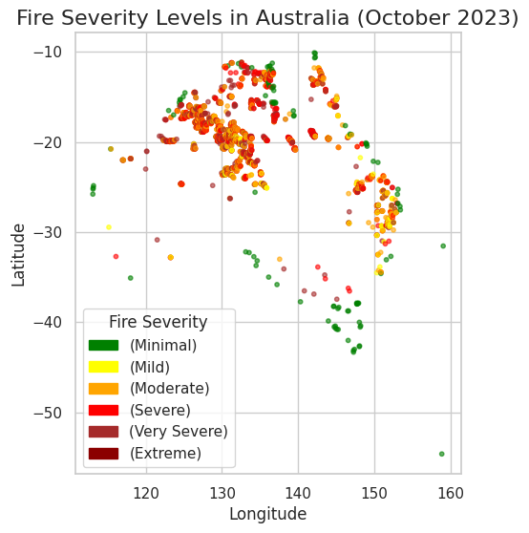

Figure : Active Fire Severity Levels Australia

### ⅱ. Temporal Analysis

* **Burned Area Trends:** Trends in burned area extents are plotted over the study period to identify temporal patterns.

Figure : Burned Area of Australia 2019-2022

# Ⅳ. Results:

## A. Land Cover Distribution:

The reclassified Land Cover map reveals the forest and shrubs dominates much of Australia’s landscape, with significant areas covered by grasslands and croplands. Water bodies and snow/ice are minimal, but they are crucial for ecological functions.

Quantitative area estimates showed (Figure 10):

* Forest (green) covers 260450 km².
* Shrubs (yellow) account for 4474151 km².
* Grasslands (orange) extend over 527369 km².
* Cropland (red) covers over 1890771 km².
* Mixed land (grey) accounted for 348860 km².
* Sparse (white) covers a very less of 314 km².
* Water (blue) bodies of 42950 km².
* Snow/ice (white) constitute the least coverage of 143696 km².

Figure : Classified Landcover Map

## B. NDVI Seasonal and Annual Patterns

The NDVI time series (Figure 5) displayed typical seasonal fluctuations reflecting vegetation growth cycles at a scale of 1000m. Peak NDVI values coincided with Australian spring and summer months, while winter months showed reduced greens.

Long-term trends suggested areas of vegetation degradation or improvement, depending on climatic conditions and land use changes. The mean NDVI (Figure 11) image provided a spatial overview of average vegetation per year

Figure :NDVI_MEAN

## C. Burned Area Analysis:

NDVI anomaly analysis (Figure 6) indicated significant vegetation loss in 2021 relative to 2020, with pronounced negative anomalies in fire-prone regions such as New South Wales and Victoria. The spatial extent of burned areas corresponded well with recorded wildfire events. These findings underscore the severe ecological impact of recent wildfires.

## D. Forest Loss Trends and Hotspots

The analysis of forest loss across Australia from 2002 to 2022 was conducted using the Hansen Global Forest Change dataset. This dataset provides annual information on forest cover change at a 30-meter resolution, allowing for detailed year-by-year assessments of deforestation patterns.

The 'loss' band of the Hansen dataset at a scale of 500m was utilized to compute annual forest loss across the Australian continent. Using Earth Engine's reduce Region function and the pixel Area method, the total loss per year was calculated in hectares. These results were compiled into a table and visualized through a line chart to highlight inter-annual variability and long-term trends.

|  |  |
| --- | --- |
| **Year** | **Forest loss (ha)** |
| 2002 | 684090.547 |
| 2003 | 1282162.009 |
| 2004 | 340613.467 |
| 2005 | 998522.17 |
| 2006 | 541056.608 |
| 2007 | 800374.107 |
| 2008 | 456361.372 |
| 2009 | 403883.513 |
| 2010 | 612254.998 |
| 2011 | 216186.831 |
| 2012 | 229662.525 |
| 2013 | 479128.043 |
| 2014 | 711667.181 |
| 2015 | 671188.055 |
| 2016 | 928166.482 |
| 2017 | 629585.934 |
| 2018 | 707880.298 |
| 2019 | 3049501.661 |
| 2020 | 4227381.148 |
| 2021 | 557322.957 |
| 2022 | 287411.426 |

Table 4.4.1Forest loss area

# ⅴDiscussion:

The integration of multi-temporal remote sensing datasets has given us valuable insights into how land cover in Australia has changed over the past two decades. By simplifying land cover classifications, we can better interpret ecological changes and quantify areas, which is essential for developing effective land management policies.

Using NDVI (Normalized Difference Vegetation Index) trends, we were able to track vegetation growth patterns and understand the impacts of disturbances, particularly wildfires. Our analysis of burned areas revealed important information about the extent and timing of wildfire damage. Additionally, our examination of forest loss supported these findings and highlighted ongoing deforestation trends.

However, there are some limitations to our study. We faced challenges related to the spatial resolution of the data, potential errors in classification, and the difficulty of distinguishing fire effects from other types of disturbances. Looking ahead, future research should focus on using higher resolution data and incorporating active fire detection methods to provide more detailed assessments.

# ⅵConclusion:

This study showcased the incredible capabilities of Google Earth Engine for monitoring the environment on a large scale.

* From the analysis, Australia lost around 8 million hectares of forest during 2019 to 2021. Noticeable spike in burned area during Black Summer is seen which indicates the major fire activity over this period.
* By land cover, NDVI (Normalized Difference Vegetation Index), forest loss, helps us to understand that significant loss occurred in shrubs, grasslands and forests during the fire event, creating a strong framework for understanding ecological changes in Australia. This information is crucial for developing sustainable land use strategies.
* Google Earth Engine efficiently visualized burned area maps with high resolution enabling rapid analysis. However, due to vast data volume and export limitations extracting results were challenging and constrained large-scale processing.
* Our findings highlight the importance of ongoing monitoring and proactive management efforts to address issues like deforestation and the impacts of wildfires. By doing so, we can help protect Australia’s unique ecosystems for future generations.

**Recommendations:**

1. **Incorporate Additional Datasets:** To enhance prediction capabilities, it is recommended to integrate additional datasets such as soil moisture, wind patterns, and socio-economic factors. Incorporating these variables can provide a more comprehensive understanding of fire dynamics and improve model accuracy.
2. **Explore Deep Learning Methods:** Exploring deep learning-based methods, such as convolutional neural networks (CNNs) and recurrent neural networks (RNNs), may further improve classifier performance. These advanced techniques have the potential to capture complex patterns in the data, leading to more accurate predictions.
3. **Refine Burn Mask:** Enhancing the burn mask through the integration of higher-resolution data and advanced image processing techniques can improve its accuracy. Refinements may include the use of object-based image analysis and the incorporation of spectral indices sensitive to burned areas.

# REFERENCES:

1. Proloy Deb, “Causes of the Widespread 2019–2020 Australian Bushfire Season.” (<https://agupubs.onlinelibrary.wiley.com/doi/full/10.1029/2020EF001671>)
2. Taylor, “New Spatial Analyses of Australian Wildfires.” (<https://www.pnas.org/doi/10.1073/pnas.2002269117>)
3. B. Jones, “Averting the Flames: How to Prevent Bushfires in Australia.” (<https://www.dryad.net/post/bushfire-prevention-in-australia>)
4. G. S. Exchange, “Clipping imagery to regions of interest with Google Earth Engine before exporting,” 23 Sept 2020. (<https://gis.stackexchange.com/questions/364901/clipping-imagery-to-regions-of-interest-with-google-earth-engine-before-exportin>)
5. Ekhi Roteta, “A Preliminary Global Automatic Burned-Area Algorithm in GEE.” (<https://www.mdpi.com/2072-4292/13/21/4298>)
6. Josep G Canadell, “Multi-Decadal Increase of Forest Burned Area in Australia.” (<https://www.nature.com/articles/s41467-021-27225-4>)
7. USGS Earth Data, “MODIS Burned Area Data Product.” (<https://lpdaac.usgs.gov/products/mcd64a1v006/>)
8. NASA, “VIIRS Burned Area Product.” (<https://viirsland.gsfc.nasa.gov/Products/NASA/BurnedAreaESDR.html>)
9. Quan Duan, Burned area detection from a single satellite image using an adaptive thresholds algorithm,” (<https://www.tandfonline.com/doi/full/10.1080/17538947.2024.2376275>)
10. Joana Parente, “Quantitative Assessment of LULC Changes and Wildfires.” (<https://www.mdpi.com/2571-6255/6/5/198>)
11. Yang Zhang, “Identifying Key Drivers of Wildfires Using Machine Learning.” (<https://agupubs.onlinelibrary.wiley.com/doi/full/10.1029/2020EF001910>)
12. Ana Militino, “Detection of burned areas with extreme gradient,” *Research Square,* 2022. ([v1_covered.pdf](https://assets-eu.researchsquare.com/files/rs-1445331/v1_covered.pdf?c=1647544512))
13. Understanding the Confusion Matrix in Machine Learning. (<https://www.geeksforgeeks.org/confusion-matrix-machine-learning/>)